Olebogeng Mmalegoso Letlape
St10465556 RI Braam Campus Group 2
>Section A
>Section B

Prog part 1
POE

Section A

ERD
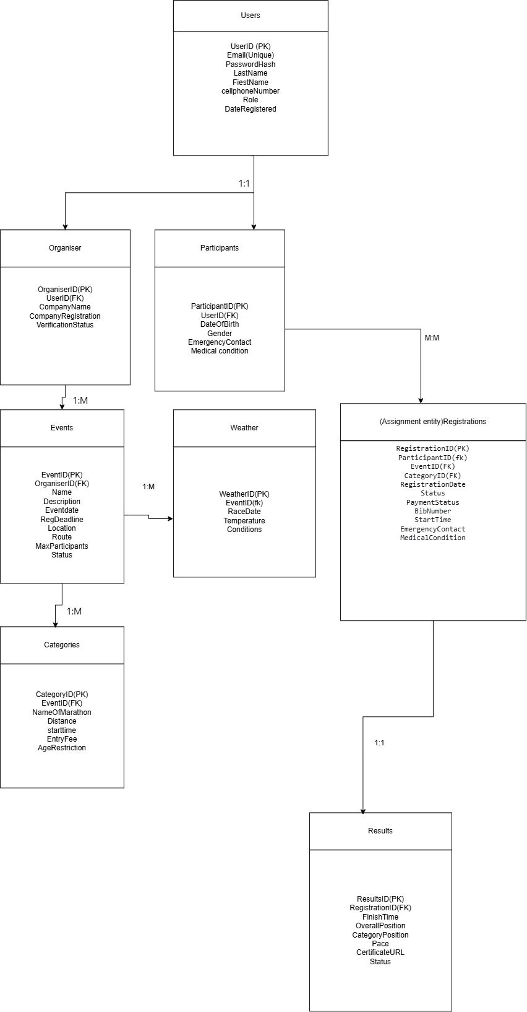

Section B

API Endpoint plan
Authentication and user management
HTTP Method | Route | Description | Role Required | Request Body | Expected Response
POST | /api/auth/register | Register a new user (Organiser or Participant) | None | { email, password, firstname, lastname, phone, role…} | 201 Created - User object with token / 400 Bad Request - Validation errors
POST | /api/auth/login | Authenticate user and return JWT token | None | { email, password} | 200 OK - Token and user info / 401 Unauthorized - Invalid credentials
POST | /api/auth/logout | Logout current user | Any | none | 200 OK - Logout successful
GET | /api/auth/me | Get current user profile | Any | none | 200 OK - User profile / 401 Unauthorized - Not logged in

Organiser Management
HTTP Method | Route | Description | Role Required | Request Body | Expected response
POST | /api/organisers | Create a new organiser profile | None (during registration) | { companyName, companyRegistration } | 201 Created - Organiser profile / 400 Bad Request - Validation errors
GET | /api/organisers/{id} | Get organiser profile by ID | Any | None | 200 OK - Organiser details / 404 Not Found
PUT | /api/organisers/{id} | Update organiser profile | Organiser | { companyName,..} | 200 OK - Updated organiser / 403 Forbidden - Not your profile
GET | /api/organisers/{id}/events | Get all events created by an organiser | Any | None | 200 OK - List of events / 404 Not Found

Event Management
HTTP Method | Route | Description | Role Required | Request Body | Expected response
POST | /api/events | Create a new event | Organiser | { nme, description, eventDate, registrationDeadLine, location, maxParticipants, categories..}
GET | /api/events | Get all events (with optional filters) | None | None
GET | /api/events/{id} | Get specific event details | None | None
PUT | /api/events/{id} | Update an event | Organiser | { name, description}
DELETE | /api/events/{id} | Delete an event | Organiser | None
GET | /api/events/{id}/categories | Get all categories for an event | Organiser | None
POST | /api/events/{id}/publish | Publish an event (make it visible) | None | None
PUT | /api/events/{id}/status | Update event status (Draft/Published/Cancelled/Completed | Organiser | { status}

Category Management
HTTP Method | Route | Description | Roles Required | Request Body | Expected Response
POST | /api/events/{id}/categories | Add category to an event | Organiser | { name, distance, starttime, entryFee, ageRestriction} | 201 Created - Category / 400 Bad Request
PUT | /api/categories/{id} | Update a category | Organiser | { name, distance} | 200 OK - Updated category / 403 Forbidden / 404 Not Found
DELETE | /api/categories/{id} | Delete a category | Organiser | None | 204 No Content / 403 Forbidden / 404 Not Found
GET | /api/categories/{id} | Get a category details | None | None | 200 OK - Category details / 404 Not Found

Registration Management
HTTP Method | Route | Description | Role Request | Request body | Expected Response
POST | /api/registrations | Register participant for an event | Participant | { eventId,CategoryId,emergencyPhone, medicalConditions ,} | 201 Created - Registration / 400 Bad Request / 409 Conflict - Already registered
GET | /api/registrations | Get all registrations for current user | Participant | None | 200 OK - List of registrations
GET | /api/registrations/{id} | Get specific registration | Any | None | 200 OK - Registration details / 404 Not Found
PUT | /api/registrations/{id} | Update registration | Participant | { emergencyContact } | 200 OK - Updated registration / 403 Forbidden / 404 Not Found
DELETE | /api/registrations/{id} | Cancel registration | Participant | None | 204 No Content / 403 Forbidden / 404 Not Found
GET | /api/events/{id}/registrations | Get all registrations for an event | Organiser | None | 200 OK - List of registrations / 403 Forbidden - Not your event / 404 Not Found
GET | /api/events/{id}/registrations/{registrationId}/payment | Process payment for registration | Participant | { paymentMethod } | 200 OK - Payment status / 400 Bad Request

Results Management
HTTP Method | Route | Description | Role Required | RequestbBody | Expected Response
POST | /api/registrations/{id}/results | Record participant result | Organiser | {FinishTime, overallPosition, categoryPosition, pace } | 201 Created - Result / 400 Bad Request / 403 Forbidden / 404 Not Found
GET | /api/registrations/{id}/results | Get result for specific registration | Any | None | 200 OK - Result details / 404 Not Found
GET | /api/participants/{id}/results | Get all results for a participant | Participant | None | 200 OK - List of results / 403 Forbidden - Not your results
GET | /api/events/{id}/results | Get all results for an event | Any | None | 200 OK - List of results
PUT | /api/results/{id} | Update a result | Organiser | { FinishTime,…} | 200 OK - Updated result / 403 Forbidden / 404 Not Found

Weather & Route Management
HTTP Method | Route | Description | Role Required | Request Body | Expected Response
POST | /api/events/{id}/weather | Add/update weather for an event | Organiser | { date, temperature, condition, windspeed, humidity} | 201 Created - Weather record / 400 Bad Request
GET | /api/events/{id}/weather/latest | Get latest weather for an event | None | None | 200 OK - Weather details / 404 Not Found
POST | /api/events/{id}/routes | Add a route to an event | Organiser | { gpFile, elevationGain, startLatitude, startLongitude, description} | 201 Created - Route details / 400 Bad Request
GET | /api/events/{id}/routes | Get all routes for an event | None | None | 200 OK - List of routes
GET | /api/routes/{id} | Get specific route details | None | None | 200 OK - Route details / 404 Not Found

Search & Dashboard
HTTP Method | Route | Description | Role Required | Request Body | Expected Response
GET | /api/search?q=keyword&type=events/participants | Search across the platform | Any | None | 200 OK - Search results
GET | /api/dashboard/organiser | Get organiser dashboard statistics | Organiser | None | 200 OK - Dashboard stats
GET | /api/dashboard/participant | Get participant dashboard statistics | Participant | None | 200 OK - Dashboard stats

Section C
